1. Write program using functions for binary tree traversals: Pre-order, In-order and Post-
order using recursive approach.
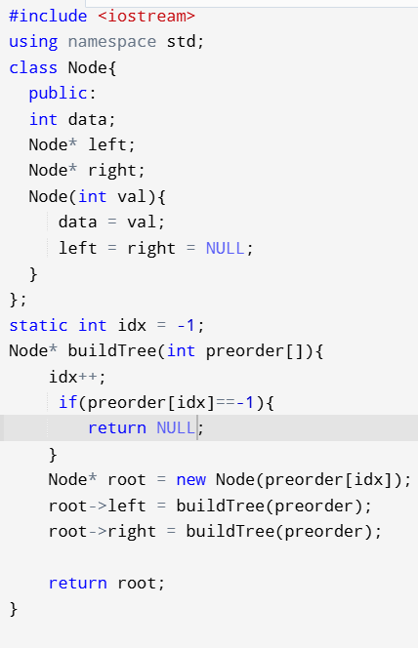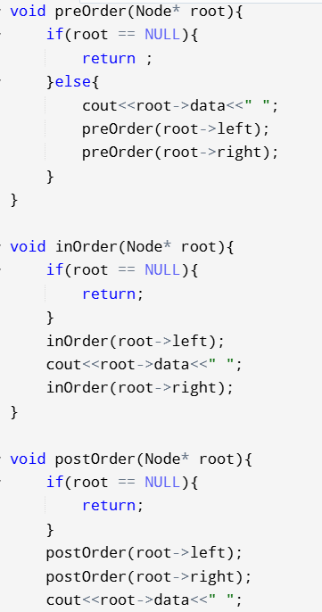
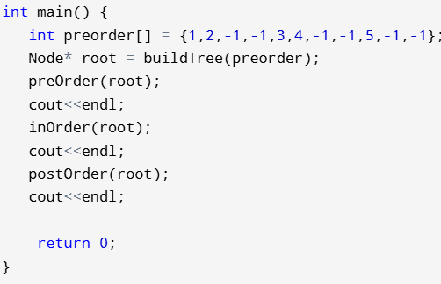
2. Implement following functions for Binary Search Trees
(a) Search a given item (Recursive & Non-Recursive)
(b) Maximum element of the BST
(c) Minimum element of the BST
(d) In-order successor of a given node the BST
(e) In-order predecessor of a given node the BST

